A simple data center for Barret Hodgson University and pharmaceutical limited

**Barret Hodgson**

**Remote Data**

**Center**

COMPUTER NETWORK PROJECT

ABDUL BASIT

BILAL ALI

MARYAM AHMED

**WHAT IS A DATA CENTER?**

A data center or data center is a building, a dedicated space within a building, or a group of buildings used to house computer systems and associated components, such as telecommunications and storage systems

**OBJECTIVE:**

To create a remote location to store highly confidential and important data for both the Barrett Hodgson university and company to ensure availability of backup in case of an emergency.

**ADVANTAGES:**

• Cost efficient.

• More data security.

• Ensure back up in case of any emergency like natural disaster or fire

**PHYSICAL MAP OF LOCATIONS:**

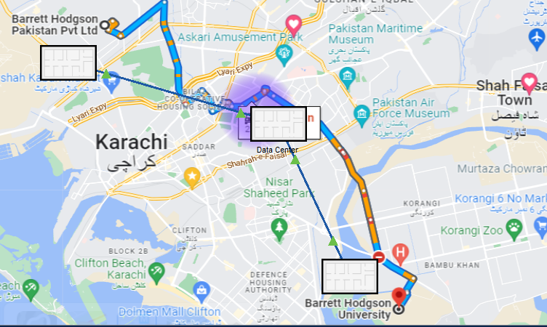

**PHYSICAL MAP:**

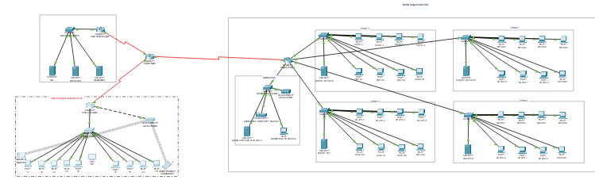

**HOW CONNECTIVITY IS ACIEVED:**

Multiple networks working simultaneously at main router

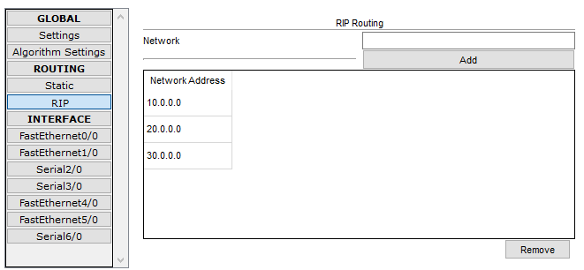

**SITE ROUTER NETWORKS**

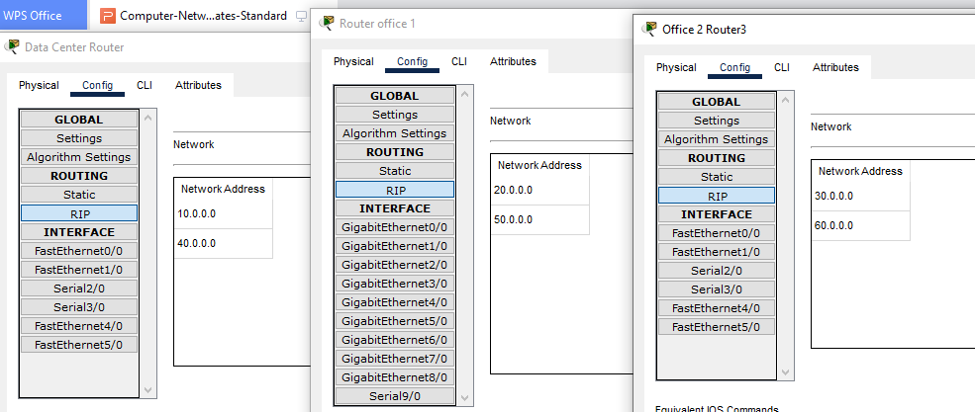

**BARRETT HODGSON UNIVERSITY**

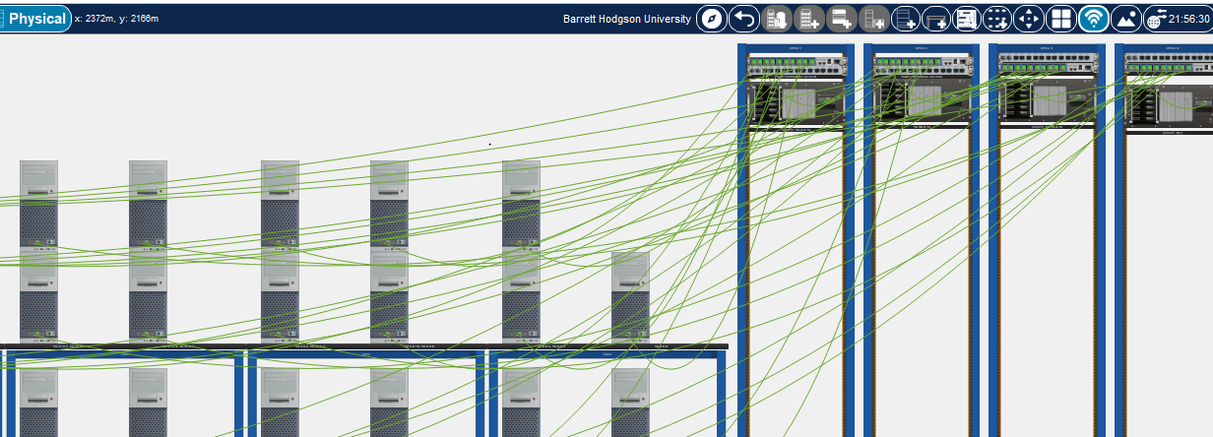

**BARRETT HODGSON PVT**

